***LAMPIRAN 1***

**SURAT PENGANTAR IJIN MENCARI DATA DARI BADAN KESATUAN BANGSA DAN POLITIK DI KELURAHAN TAMAN KECAMATAN TAMAN KOTA MADIUN** 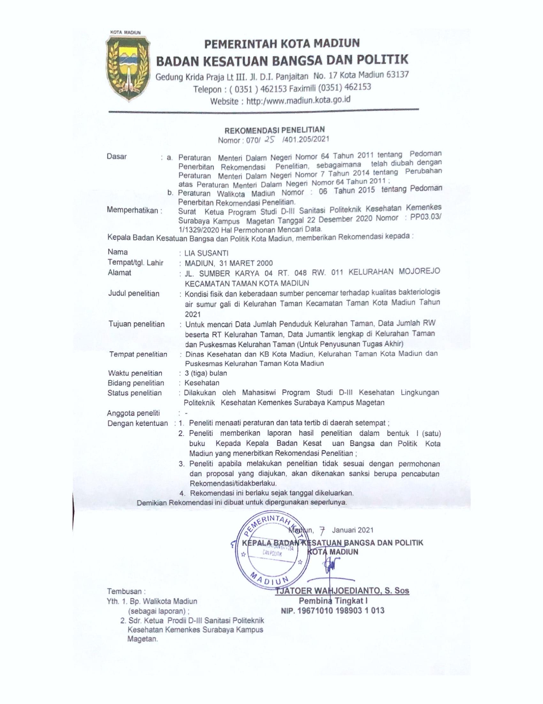

***LAMPIRAN 2***

**SURAT PENGANTAR IJIN MENCARI DATA DARI KECAMATAN TAMAN KE KELURAHAN TAMAN KOTA MADIUN**

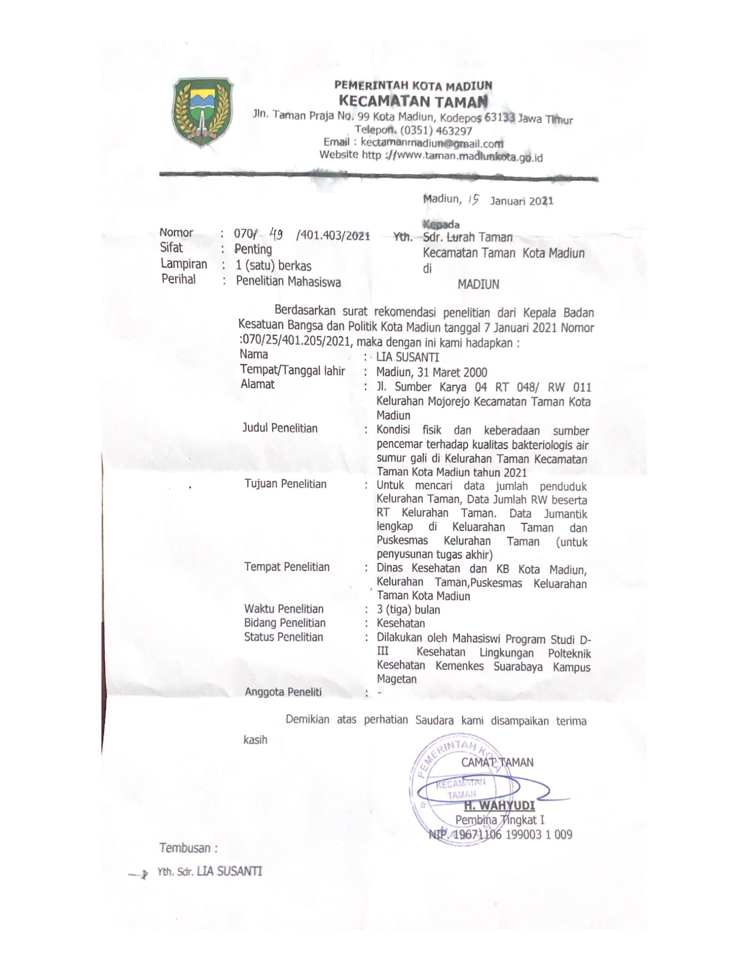

***LAMPIRAN 3***

**SURAT PENGANTAR IJIN MENCARI DATA DARI DINAS KESEHATAN, PENGENDALIAN PENDUDUK DAN KELUARGA BENCANA KE PUSKESMAS DEMANGAN KOTA MADIUN**

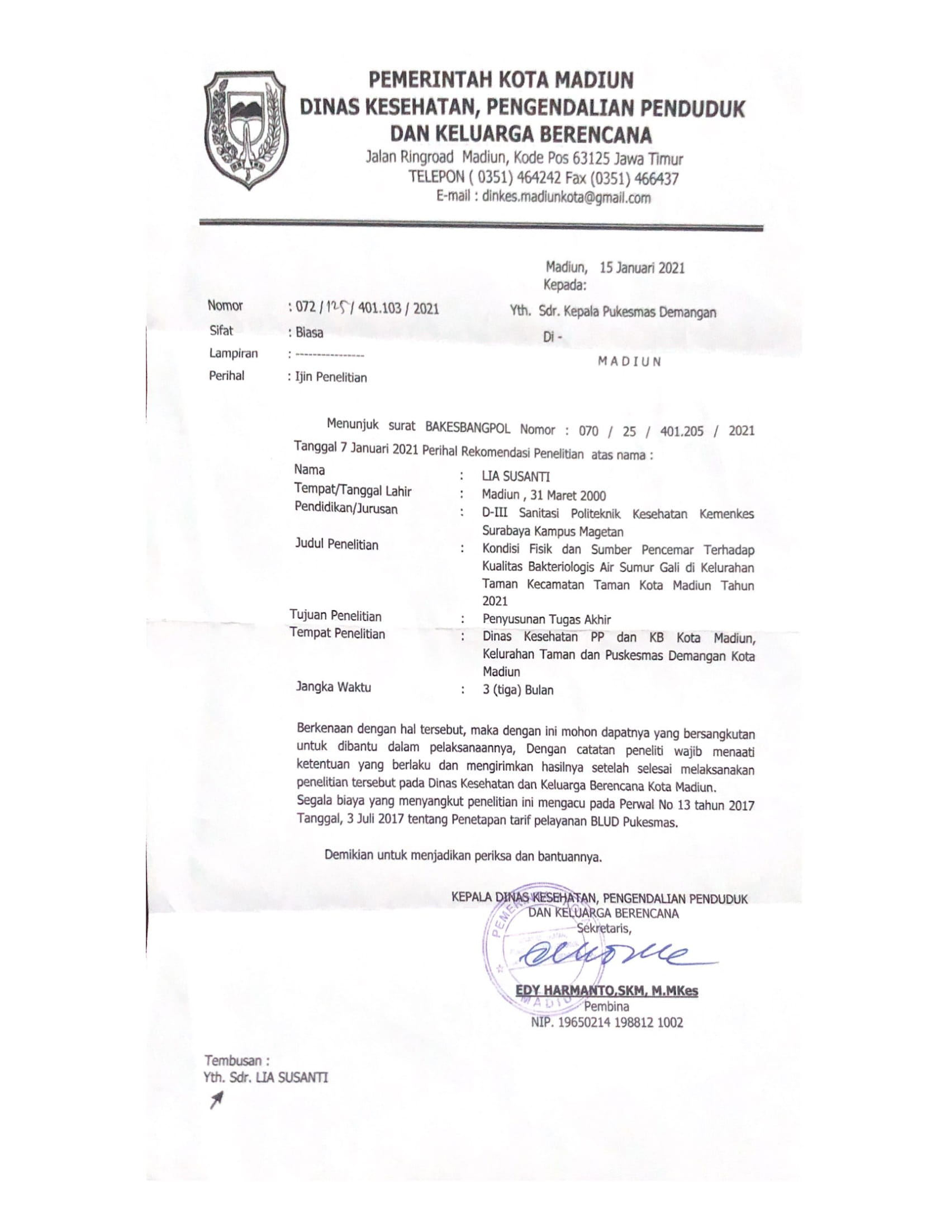

***LAMPIRAN 4***

**HASIL DATA OBSERVASI LANGSUNG DI KELURAHAN TAMAN KECAMATAN TAMAN KOTA MADIUN**

|  |  |  |  |  |  |  |  |  |
| --- | --- | --- | --- | --- | --- | --- | --- | --- |
| Kode Sumur | Bibir Sumur | Kategori Bibir Sumur | Dinding sumur | Kategori Dinding Sumur | Lantai sumur | Kategori Lantai Sumur | Jarak Pencemar | Kategori Jarak Pencemar |
| A1 | 70 | 2 | 280 | 1 | 160 | 2 | 650 | 1 |
| A2 | 80 | 2 | 220 | 1 | 135 | 2 | 950 | 1 |
| A3 | 75 | 2 | 275 | 1 | 150 | 2 | 1500 | 1 |
| A4 | 50 | 1 | 300 | 2 | 90 | 1 | 700 | 1 |
| A5 | 75 | 2 | 325 | 2 | 105 | 2 | 890 | 1 |
| A6 | 65 | 1 | 265 | 1 | 140 | 2 | 900 | 1 |
| A7 | 58 | 1 | 262 | 1 | 95 | 1 | 500 | 1 |
| A8 | 70 | 2 | 270 | 1 | 110 | 2 | 900 | 1 |
| A9 | 75 | 2 | 305 | 2 | 120 | 2 | 1400 | 1 |
| A10 | 80 | 2 | 230 | 1 | 155 | 2 | 1300 | 1 |
| A11 | 65 | 1 | 305 | 2 | 80 | 1 | 500 | 1 |
| A12 | 80 | 2 | 310 | 2 | 157 | 2 | 700 | 1 |
| A13 | 75 | 2 | 325 | 2 | 150 | 2 | 2000 | 1 |
| A14 | 80 | 2 | 340 | 2 | 80 | 1 | 840 | 1 |
| A15 | 70 | 2 | 260 | 1 | 184 | 2 | 550 | 1 |
| A16 | 80 | 2 | 240 | 1 | 152 | 2 | 620 | 1 |
| A17 | 65 | 1 | 255 | 1 | 90 | 1 | 500 | 1 |
| A18 | 70 | 2 | 270 | 1 | 120 | 2 | 850 | 1 |
| A19 | 65 | 1 | 250 | 1 | 92 | 1 | 500 | 1 |
| A20 | 80 | 2 | 310 | 2 | 180 | 2 | 1800 | 1 |
| A21 | 70 | 2 | 245 | 1 | 130 | 2 | 750 | 1 |
| A22 | 70 | 2 | 310 | 2 | 140 | 2 | 850 | 1 |
| A23 | 80 | 2 | 270 | 1 | 150 | 2 | 600 | 1 |
| A24 | 75 | 2 | 270 | 1 | 170 | 2 | 850 | 1 |
| A25 | 80 | 2 | 290 | 1 | 80 | 1 | 600 | 1 |

***LAMPIRAN 5***

**HASIL PEMERIKSAAN LABORATORIUM MIKROBIOLOGI PRODI DIII SANITASI KAMPUS MAGETAN**

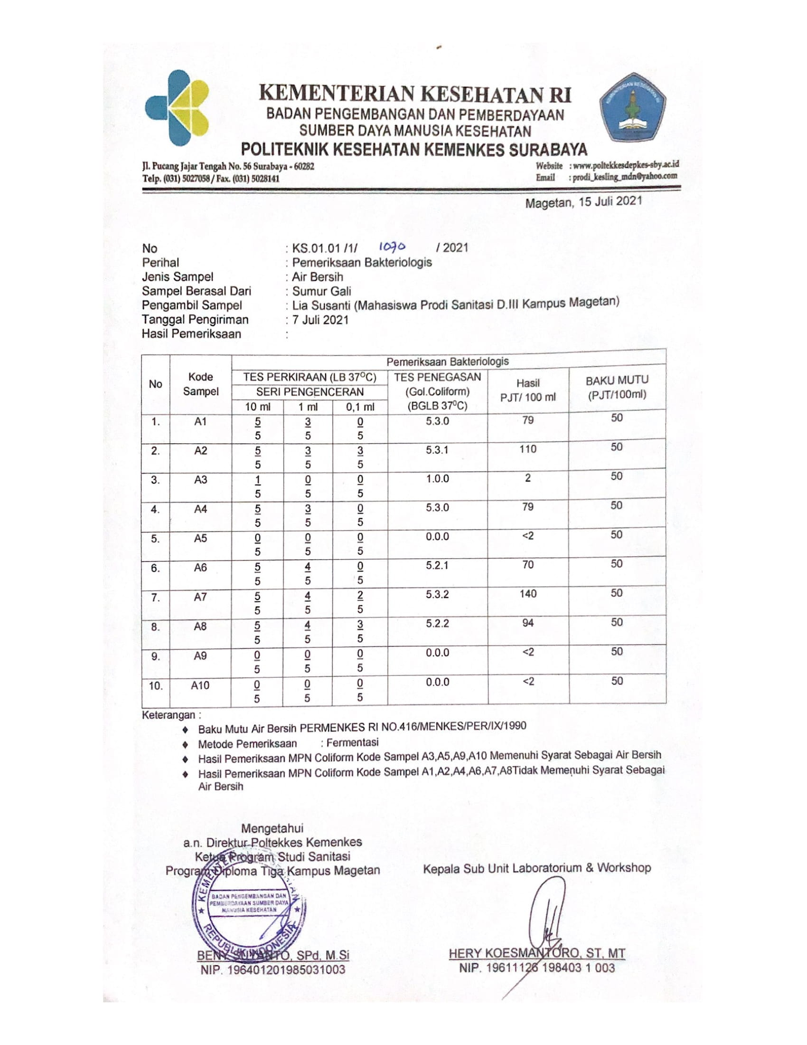

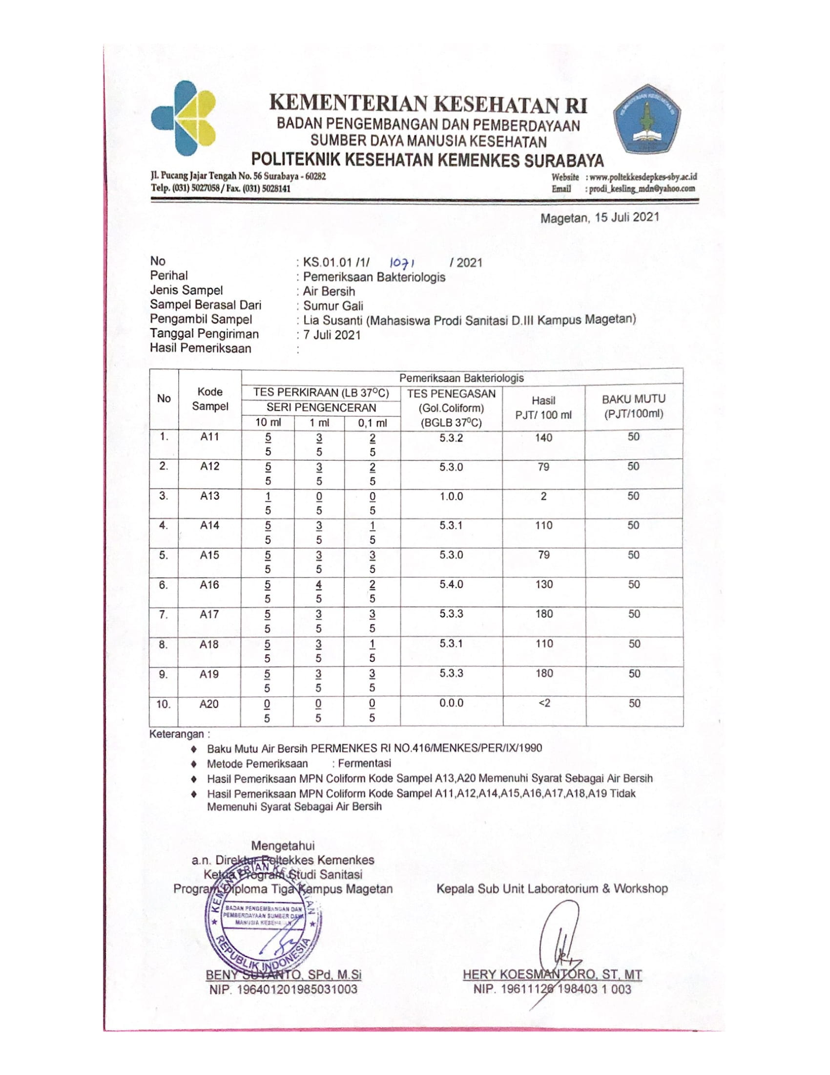

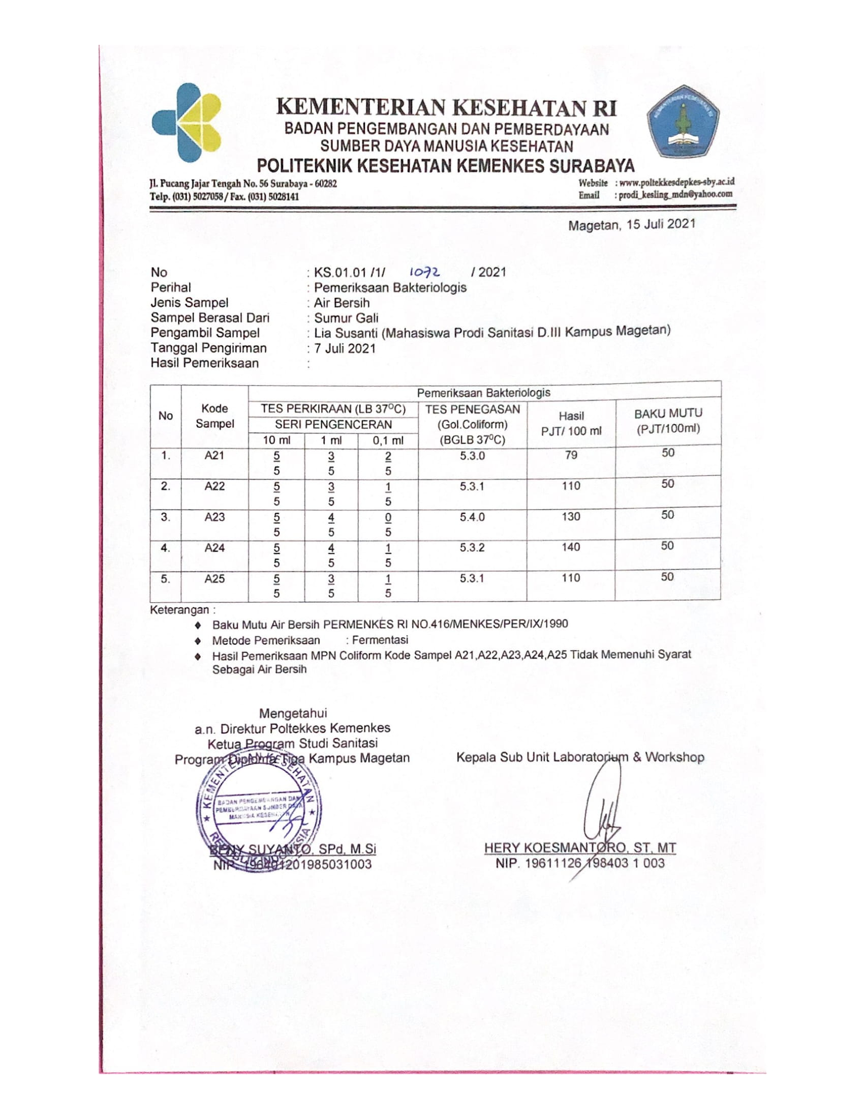

***LAMPIRAN 6***

**HASIL ANALISA**

| **Bibir Sumur** | | | | | |
| --- | --- | --- | --- | --- | --- |
|  |  | Frequency | Percent | Valid Percent | Cumulative Percent |
| Valid | < 70 atau Tidak Memenuhi Syarat | 6 | 24.0 | 24.0 | 24.0 |
| >= 70 atau Memenuhi Syarat | 19 | 76.0 | 76.0 | 100.0 |
| Total | 25 | 100.0 | 100.0 |  |

| **Dinding Sumur** | | | | | |
| --- | --- | --- | --- | --- | --- |
|  |  | Frequency | Percent | Valid Percent | Cumulative Percent |
| Valid | <3 meter atau Tidak Memenuhi Syarat | 16 | 64.0 | 64.0 | 64.0 |
| >= 3 meter atau Memenuhi Syarat | 9 | 36.0 | 36.0 | 100.0 |
| Total | 25 | 100.0 | 100.0 |  |

| **Lantai Sumur** | | | | | |
| --- | --- | --- | --- | --- | --- |
|  |  | Frequency | Percent | Valid Percent | Cumulative Percent |
| Valid | <1meter atau Tidak Memenuhi Syarat | 7 | 28.0 | 28.0 | 28.0 |
| >= 1 meter atau Memenuhi Syarat | 18 | 72.0 | 72.0 | 100.0 |
| Total | 25 | 100.0 | 100.0 |  |

| **Jarak Sumber Pencemar** | | | | | |
| --- | --- | --- | --- | --- | --- |
|  |  | Frequency | Percent | Valid Percent | Cumulative Percent |
| Valid | <10 meter atau Tidak Memenuhi Syarat | 20 | 80.0 | 80.0 | 80.0 |
| >= 10 meter atau Memenuhi Syarat | 5 | 20.0 | 20.0 | 100.0 |
| Total | 25 | 100.0 | 100.0 |  |

| **Kualitas Bakteriologis** | | | | | |
| --- | --- | --- | --- | --- | --- |
|  |  | Frequency | Percent | Valid Percent | Cumulative Percent |
| Valid | <50 PTJ/100ml atau Memenuhi syarat | 6 | 24.0 | 24.0 | 24.0 |
| >=50 PTJ/100ml atau Tidak memenuhi syarat | 19 | 76.0 | 76.0 | 100.0 |
| Total | 25 | 100.0 | 100.0 |  |

**Crosstabs**

| **Bibir Sumur * Kualitas Bakteriologis Crosstabulation** | | | | | |
| --- | --- | --- | --- | --- | --- |
|  |  |  | Kualitas Bakteriologis | | Total |
|  |  |  | <=50 PTJ/100ml atau Memenuhi Syarat | >50 PTJ/100ml atau Tidak Memenuhi Syarat |
| Bibir Sumur | < 70 atau Tidak Memenuhi Syarat | Count | 0 | 6 | 6 |
| % of Total | .0% | 24.0% | 24.0% |
| >= 70 atau Memenuhi Syarat | Count | 6 | 13 | 19 |
| % of Total | 24.0% | 52.0% | 76.0% |
| Total | | Count | 6 | 19 | 25 |
| % of Total | 24.0% | 76.0% | 100.0% |

| **Dinding Sumur * Kualitas Bakteriologis Crosstabulation** | | | | | |
| --- | --- | --- | --- | --- | --- |
|  |  |  | Kualitas Bakteriologis | | Total |
|  |  |  | <=50 PTJ/100ml atau Memenuhi Syarat | >50 PTJ/100ml atau Tidak Memenuhi Syarat |
| Dinding Sumur | <3 meter atau Tidak Memenuhi Syarat | Count | 2 | 14 | 16 |
| % of Total | 8.0% | 56.0% | 64.0% |
| >= 3 meter atau Memenuhi Syarat | Count | 4 | 5 | 9 |
| % of Total | 16.0% | 20.0% | 36.0% |
| Total | | Count | 6 | 19 | 25 |
| % of Total | 24.0% | 76.0% | 100.0% |

| **Lantai Sumur * Kualitas Bakteriologis Crosstabulation** | | | | | |
| --- | --- | --- | --- | --- | --- |
|  |  |  | Kualitas Bakteriologis | | Total |
|  |  |  | <=50 PTJ/100ml atau Memenuhi Syarat | >50 PTJ/100ml atau Tidak Memenuhi Syarat |
| Lantai Sumur | <1meter atau Tidak Memenuhi Syarat | Count | 0 | 7 | 7 |
| % of Total | .0% | 28.0% | 28.0% |
| >= 1 meter atau Memenuhi Syarat | Count | 6 | 12 | 18 |
| % of Total | 24.0% | 48.0% | 72.0% |
| Total | | Count | 6 | 19 | 25 |
| % of Total | 24.0% | 76.0% | 100.0% |

| **Jarak Sumber Pencemar * Kualitas Bakteriologis Crosstabulation** | | | | | |
| --- | --- | --- | --- | --- | --- |
|  |  |  | Kualitas Bakteriologis | | Total |
|  |  |  | <=50 PTJ/100ml atau Memenuhi Syarat | >50 PTJ/100ml atau Tidak Memenuhi Syarat |
| Jarak Sumber Pencemar | <10 meter atau Tidak Memenuhi Syarat | Count | 1 | 19 | 20 |
| % of Total | 4.0% | 76.0% | 80.0% |
| >= 10 meter atau Memenuhi Syarat | Count | 5 | 0 | 5 |
| % of Total | 20.0% | .0% | 20.0% |
| Total | | Count | 6 | 19 | 25 |
| % of Total | 24.0% | 76.0% | 100.0% |

***LAMPIRAN 7***

**DOKUMENTASI**

|  |  |
| --- | --- |
|  |  |
| Gambar 1 pengukuran dinding sumur | Gambar 2 pengukuran lantai sumur |
|  |  |
| Gambar 3 pengukuran dinding sumur | Gambar 4 hasil pengukuran dinding sumur |
|  |  |
| Gambar 5 pengambilan sampel air | Gambar 6 bibir sumur |
|  |  |
| Gambar 7 dinding sumur yang di plester | Gambar 8 dinding sumur yang tidak di plester |

***LAMPIRAN 8***

**TURNITIN**

